SMART VOTE
MEMBERS:

- Harshita Goyal : 2410990338
- Ananya Mahajan : 2410990919
- Amisha Jindal : 2410990917

SmartVote: Secure Online Voting Platform

Introduction
Voting is a vital process in any democratic institution, ensuring fair representation and collective decision-making. Traditional voting methods, such as paper ballots or centralized e-voting systems, often face several challenges—such as lack of accessibility, security concerns, logistical issues, and delayed results.
SmartVote is a modern, blockchain-based online voting platform designed to overcome these challenges by offering a secure, user-friendly, and transparent system accessible from any device. It ensures voting integrity, real-time transparency, and wider accessibility for voters, administrators, and policymakers.

Problem Overview
Existing voting systems suffer from multiple issues, including:
  - Security risks such as vote tampering, unauthorized access, and manipulation.
  - Inefficient processes, especially in large-scale elections, leading to delays in result declaration.
  - Limited accessibility for voters who cannot attend physical polling stations.
  - Lack of transparency in verifying vote legitimacy and election outcomes.
  - Poor user experience in legacy digital platforms, which often lack responsive and mobile-friendly design.

SmartVote addresses these issues by combining blockchain technology, modern web design, and accessibility best practices.

Objectives
The primary objectives of SmartVote are:
- Secure & Tamper-Proof Voting – Implement blockchain technology to ensure votes cannot be altered or deleted once cast.

- Universal Accessibility – Provide cross-device compatibility with a mobile-friendly and responsive UI.

- Transparency & Trust – Enable real-time result veriﬁcation and publicly auditable ledgers.

- Improved Voter Experience – Offer a simple, intuitive interface for voters, candidates, and administrators.

- Eﬃcient Election Management – Equip administrators with tools for creating, monitoring, and analyzing elections.

Scope of the Project
The SmartVote system supports:
  - Voter Management – Secure voter registration, authentication, and access control.

  - Online Voting – Easy, encrypted voting mechanism ensuring each voter casts exactly one vote.

  - Real-Time Result Tracking – Transparent analytics dashboard with live updates.

  - Admin Management – Tools for election setup, candidate proﬁles, user monitoring, and reporting.

  - Accessibility Features – Responsive design, light/dark modes, and clear navigation for wider inclusivity.

Signiﬁcance of the Project

SmartVote provides a secure, modern, and accessible voting platform, solving many of the long-standing problems in traditional elections. The system ensures:

  - Trustworthy Elections – Immutable blockchain records prevent manipulation.

  - Faster, Transparent Results – Real-time dashboards enhance credibility.

  - Cost-Eﬃciency – Reduces infrastructure needs compared to physical polling.

  - Wider Participation – Mobile accessibility enables remote voting for all.

  - Improved Voter Conﬁdence – Easy-to-use design boosts engagement.

Technical

  - Frontend: HTML, CSS (with CSS variables for theming)

  - UI/UX: Responsive layout, modern hero section, dark/light modes

Main Entities & Relationships:

Voter
  - VoterID (Primary Key)
  - Name
  - Email
  - PasswordHash
  - Role (Voter/Admin)
  - Status

Election
  - ElectionID (Primary Key)
  - Title
  - Description
  - StartTime
  - EndTime
  - Status

Candidate
  - CandidateID (Primary Key)
  - Name
  - ElectionID (Foreign Key)
  - Party/Group (optional)

Vote
  - VoteID (Primary Key)
  - VoterID (Foreign Key)
  - ElectionID (Foreign Key)
  - CandidateID (Foreign Key)
  - Timestamp

Relationships in SmartVote Voting System

  - Voter–Vote: One-to-Many (One vote per voter per election)
  - Election–Candidate: One-to-Many
  - Vote–Candidate: Many-to-One
  - Voter–Election: Many-to-Many

ER MODEL AND DIAGRAM:

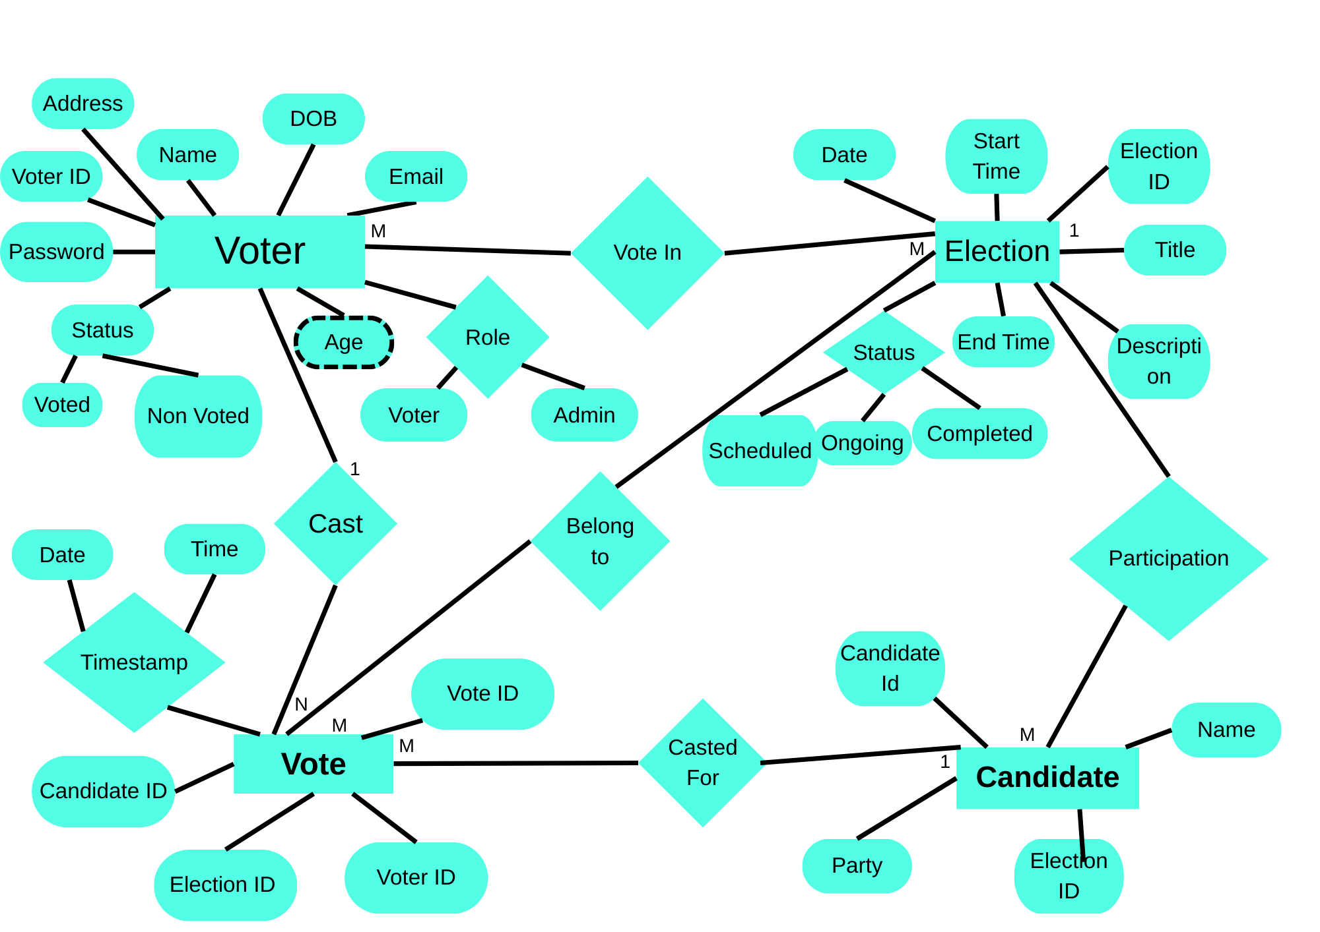

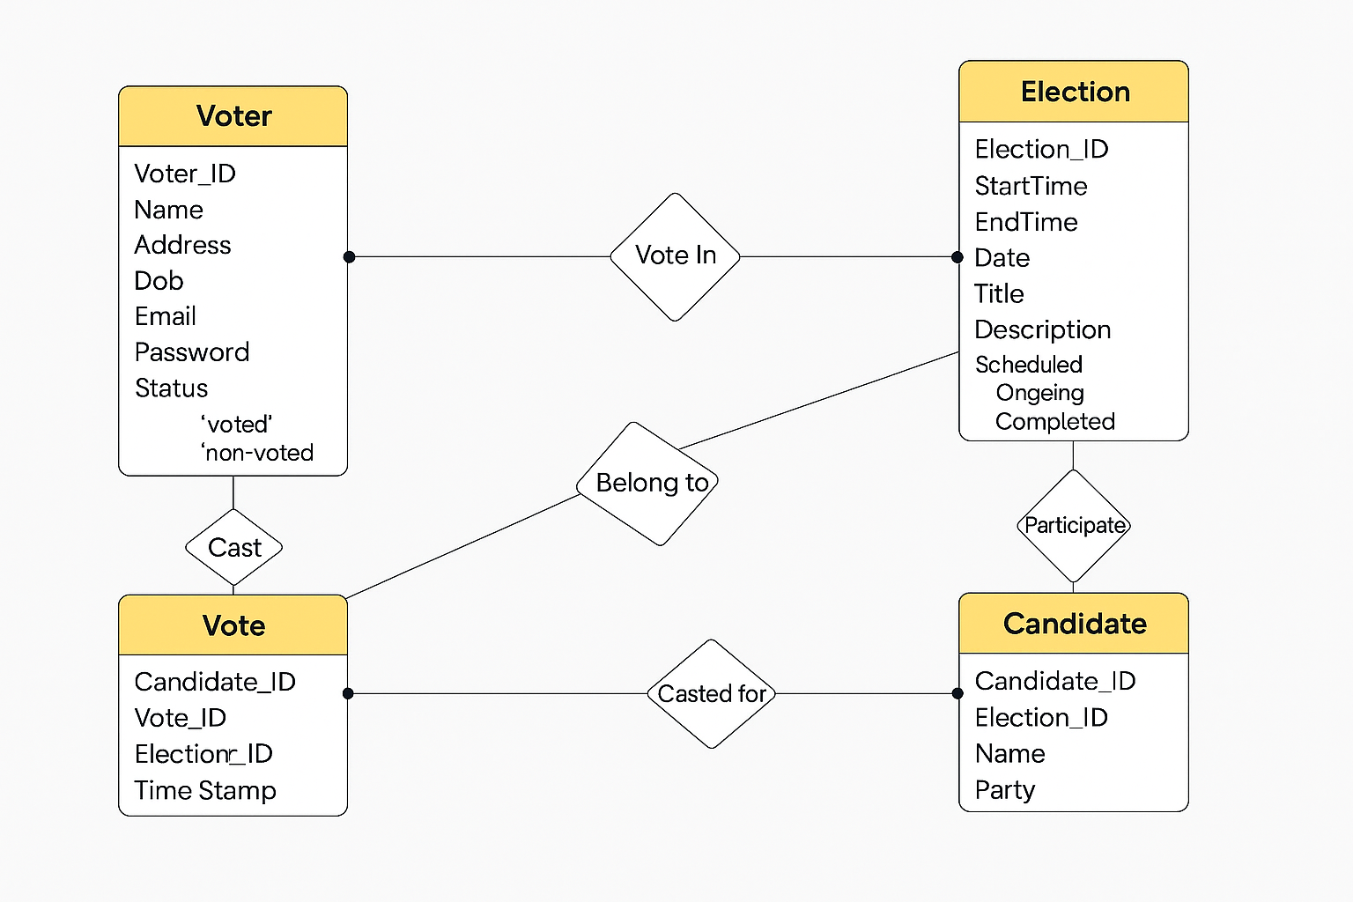

Relational Model (Schema) for SmartVote Online Voting System
  - Voter
(VoterID [PK], Name, Email, PasswordHash, Role, Status)
  - Election
(ElectionID [PK], Title, Description, StartTime, EndTime, Status)
  - Candidate
(CandidateID [PK], Name, ElectionID [FK], Party/Group)
  - Vote
(VoteID [PK], VoterID [FK], ElectionID [FK], CandidateID [FK], Timestamp)

Relational Algebra (RA):

- Get names of voters who have cast a vote.
π_fullName(VoterProfile ⨝ Ballots ⨝ Votes)

- Find all votes for election “E101”.
σ_electionId = 'E101'(Votes)

- List names of candidates in election “E101”.
π_name(Candidates ⨝ σ_electionId = 'E101'(Elections))

- Get emails of users with admin role.
π_email(σ_role = 'Admin'(Users))

- Find all elections scheduled to start after 1-Sep-2025.
σ_startAt > '2025-09-01'(Elections)

- List all ballot tokens issued but not used.
π_tokenHash(σ_usedAt = NULL(Ballots))

- Get names of voters eligible for election “E101”.
π_fullName(VoterProfile ⨝ EligibilityRules ⨝ σ_electionId = 'E101'(Elections))

- Find all votes cast for candidate “C201”.
σ_choiceJson LIKE '%C201%'(Votes)

- List all events in the audit log for election “E101”.
σ_refType = 'Election' ∧ refId = 'E101'(AuditLogs)

- Get all elections with more than 1000 votes cast.
π_id(σ_voteCount > 1000(Elections ⨝ (Votes ⨝ Ballots)))

- Find all users who have not verified their email.
π_email(σ_status != 'Verified'(Users))

- List all parties with more than 5 candidates.
π_name(σ_candidateCount > 5(Parties ⨝ Candidates))

- Get all results snapshots for election “E101”.
σ_electionId = 'E101'(ResultSnapshots)

- Find all voters from “CSE” department.
π_fullName(σ_dept = 'CSE'(VoterProfile))

- List all elections with status “Open”.
π_id(σ_status = 'Open'(Elections))

- Get all votes cast on 25-Aug-2025.
σ_castAt = '2025-08-25'(Votes)

- Find all candidates who belong to party “P101”.
π_name(Candidates ⨝ σ_partyId = 'P101'(Parties))

- List all audit log entries by user “U501”.
σ_actorUserId = 'U501'(AuditLogs)

- Get all ballots for voter “V301”.
σ_voterId = 'V301'(Ballots)

- Find all elections with type “Ranked-Choice”.
π_id(σ_type = 'RCV'(Elections))

- List all users who have requested password reset.
π_email(σ_event = 'PasswordReset'(AuditLogs ⨝ Users))

- Get all votes with trackerHash published in results.
π_trackerHash(Votes ⨝ ResultSnapshots)

- Find all candidates with no votes.
π_name(Candidates) - π_choiceJson(Votes)

- List all elections managed by admin “A101”.
π_id(Elections ⨝ σ_actorUserId = 'A101'(AuditLogs))

- Get all voters who have voted in more than one election.
π_fullName(σ_voteCount > 1(VoterProfile ⨝ Ballots ⨝ Votes))

